Machine Learning - Manipulated Data

|  |  |  |  |  |  |  |
| --- | --- | --- | --- | --- | --- | --- |
| **Algorithms** | **Accuracy** | **Precision** | **Recall** | **F1-score** | **AUC-ROC** | **Training Time (s)** |
| **KNN** | 0.699440 | 0.714897 | 0.663076 | 0.688012 | 0.699425 | 0.06 |
| **Random Forest** | 0.705615 | 0.725094 | 0.661968 | 0.692095 | 0.705598 | 754.80 |
| **XGBoost** | 0.694629 | 0.716838 | 0.643015 | 0.677923 | 0.694609 | 2.19 |
| **Decision Tree** | 0.608313 | 0.608041 | 0.608692 | 0.608366 | 0.608314 | 71.48 |
| **Extra Trees** | 0.693728 | 0.717489 | 0.638699 | 0.675805 | 0.693706 | 198.99 |

**Table:** Performance Comparison on Manipulated Dataset

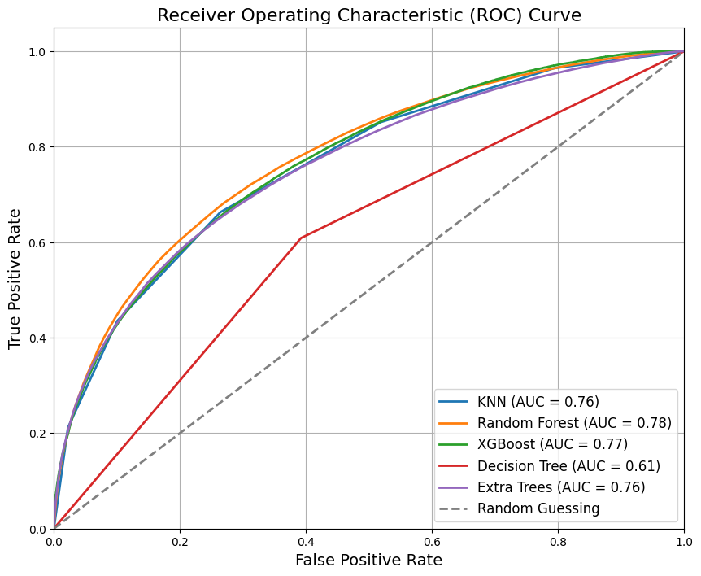

**Figure:** ROC Curve Analysis on Manipulated Dataset.

Classification Reports - Manipulated Data

**KNN:**

**precision recall f1-score support**

0 0.69 0.74 0.71 77676

1 0.71 0.66 0.69 77614

accuracy 0.70 155290

macro avg 0.70 0.70 0.70 155290

weighted avg 0.70 0.70 0.70 155290

**Random Forest:**

**precision recall f1-score support**

0 0.69 0.75 0.72 77676

1 0.73 0.66 0.69 77614

accuracy 0.71 155290

macro avg 0.71 0.71 0.71 155290

weighted avg 0.71 0.71 0.71 155290

**XGBoost:**

**precision recall f1-score support**

0 0.68 0.75 0.71 77676

1 0.72 0.64 0.68 77614

accuracy 0.69 155290

macro avg 0.70 0.69 0.69 155290

weighted avg 0.70 0.69 0.69 155290

**Decision Tree:**

**precision recall f1-score support**

0 0.61 0.61 0.61 77676

1 0.61 0.61 0.61 77614

accuracy 0.61 155290

macro avg 0.61 0.61 0.61 155290

weighted avg 0.61 0.61 0.61 155290

**Extra Trees:**

**precision recall f1-score support**

0 0.67 0.75 0.71 77676

1 0.72 0.64 0.68 77614

accuracy 0.69 155290

macro avg 0.70 0.69 0.69 155290

weighted avg 0.70 0.69 0.69 155290

Confusion Matrix - Manipulated Data

